What are the top business risks?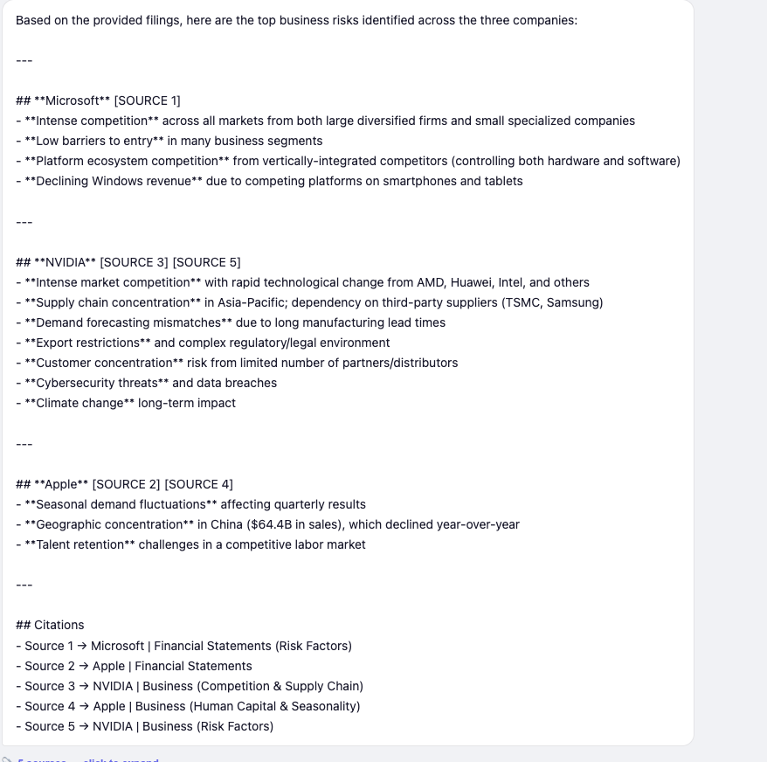

What does the company say about revenue growth or business performance?

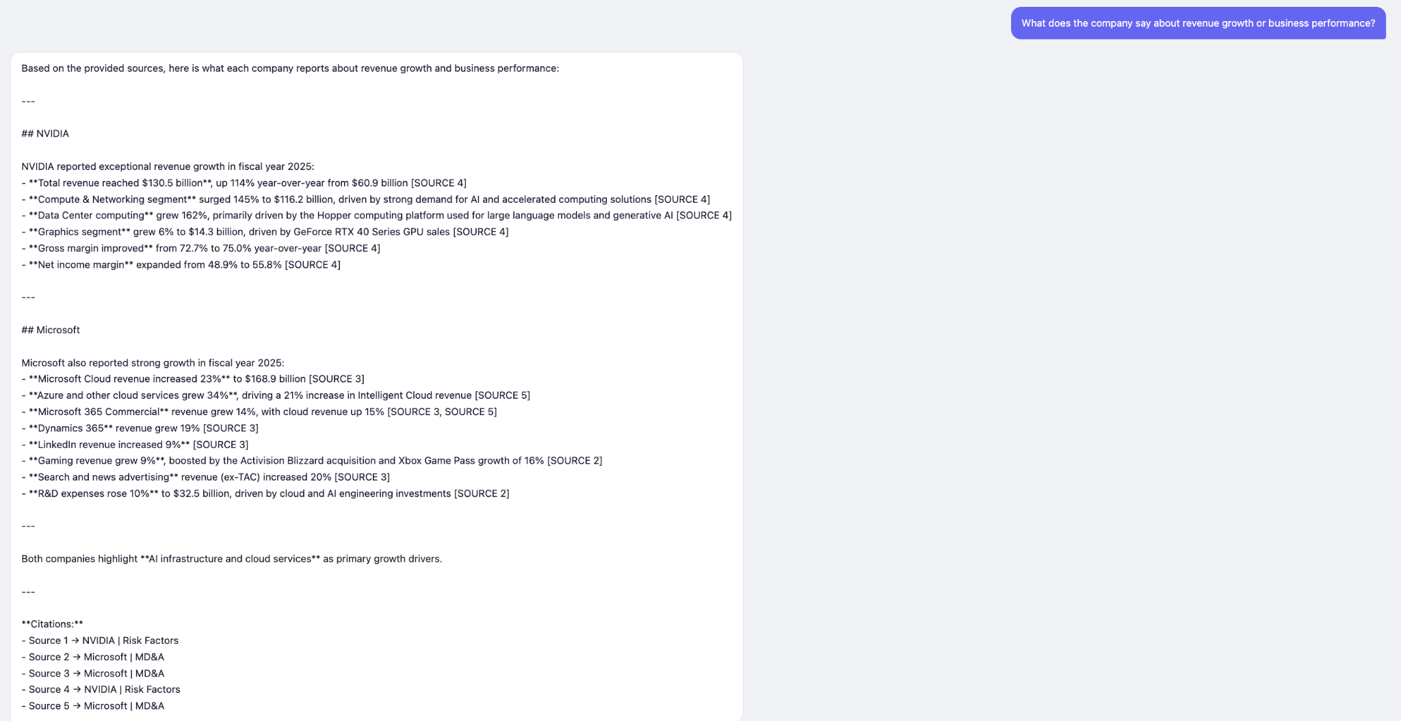

What are the company’s main business segments or operating priorities?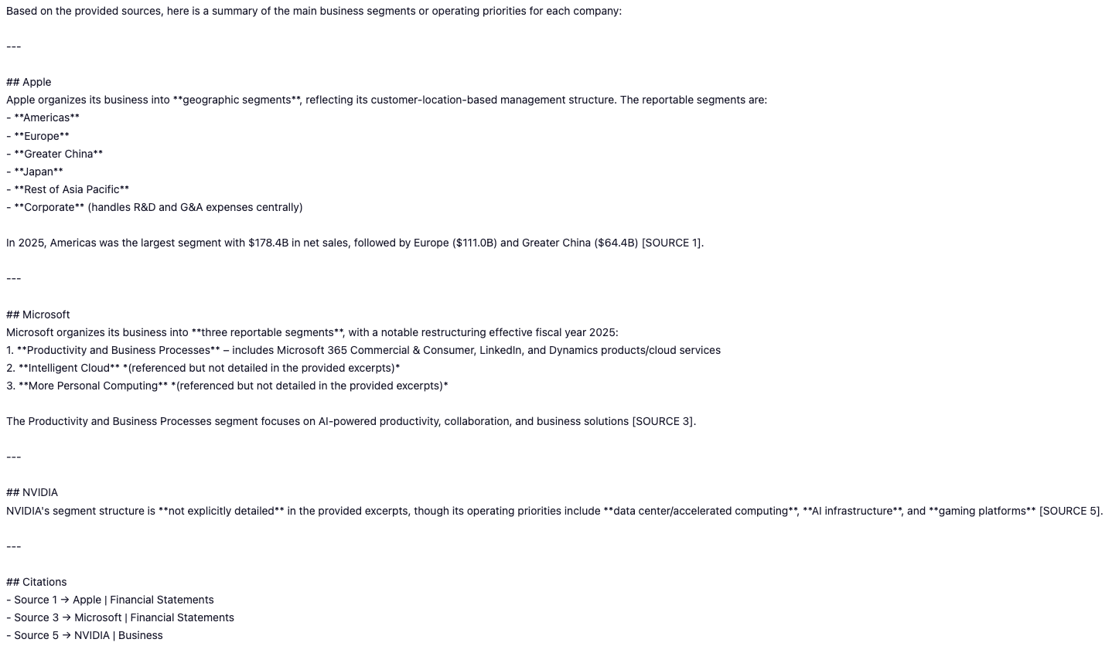

Compare risk factors between apple and nvidia

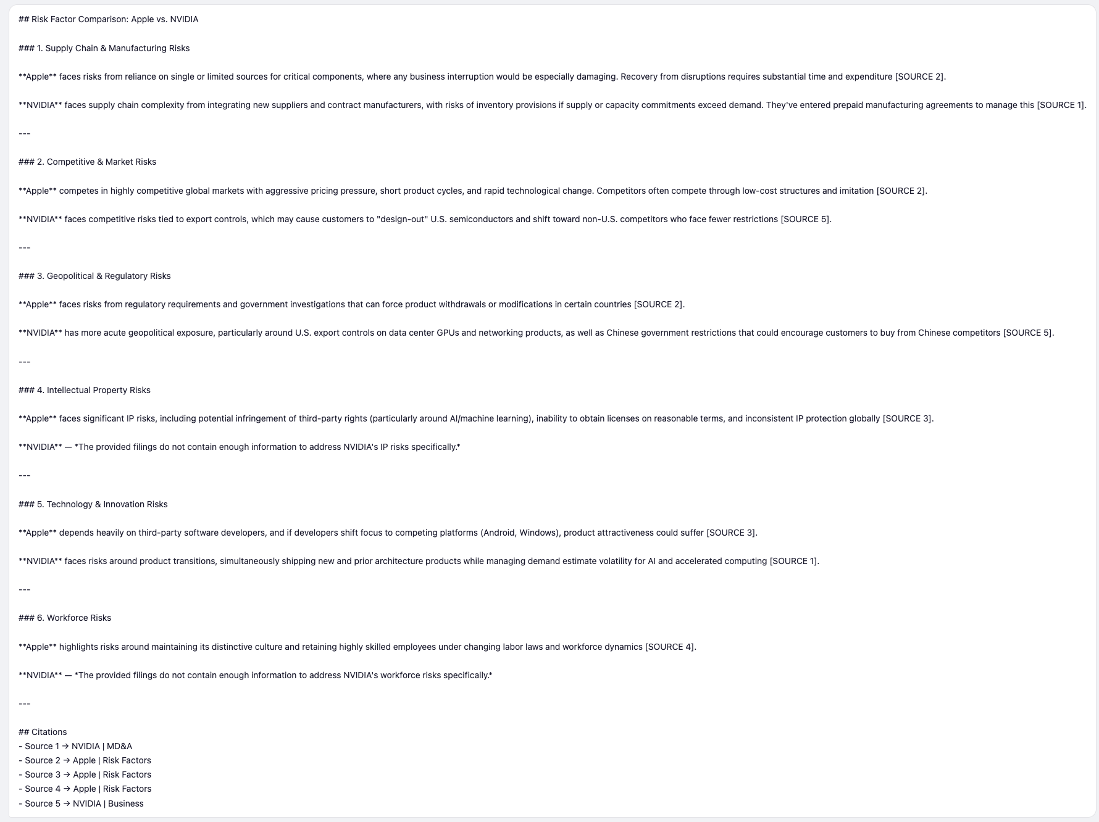
What themes appear repeatedly in management discussion?
